6.11: For the T-Rex, . The person’s velocity would be 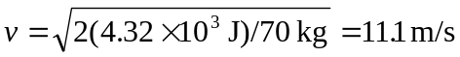, or about 40 km/h.

